  Our Vision
  “Our vision is to provide a learning journey that enables our pupils to flourish, thrive and belong as unique individuals. We want all of our pupils to develop the knowledge, skills and character to lead an exceptional life"
  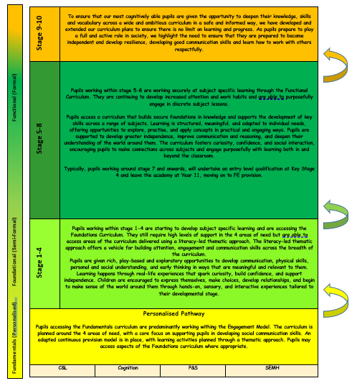
  CPA Progressive PathwaYs
  Learning values
  C – community
  - develop positive social relationships which are at the heart of our thriving school community.
  - develop positive links with the local community and promote flexible approaches to learning and social opportunities.
  - develop a range of skills, empowering our learners to become active members of the community.
  A – achievement
  - provide a broad and balanced curriculum that allows individual learners to achieve.
  - recognise that each learner is unique and ensure that their individual talents are fostered.
  - ensure that all learners have opportunities to celebrate success, and are supported to reach their aspirations.
  R – respect
  - provide an environment where everyone is equally valued and feels a sense of belonging.
  - encourage our learners to develop personal independence and an ability to respect the rights and views of others.
  - support learners to communicate their feelings and needs, to make appropriate choices and develop positive behaviours.
  E – enjoyment
  - engage our learners in fun, exciting, stimulating learning opportunities.
  - nurture our learners' confidence and self-esteem by building the skills that allow them to function effectively in their community.
  - develop our learner's skills to make friends, form social relationships and engage in team work.
  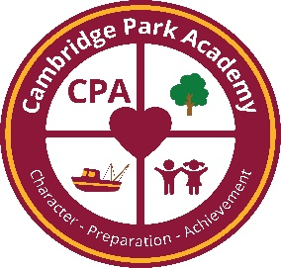
  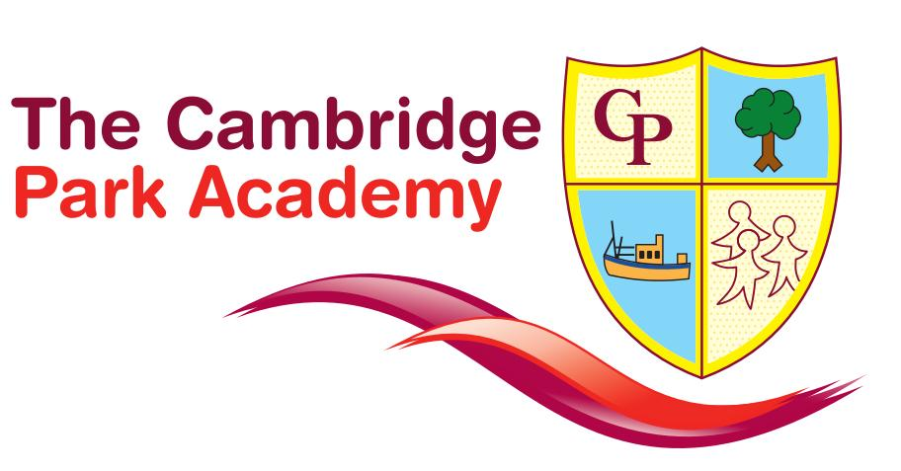

Our Curriculum Aims

Our Curriculum is underpinned by four key areas of learning designed to support our pupils to become:
- ambitious, capable learners, ready to face challenges in life, both at school and the wider world
- enterprising, creative contributors, ready to play a full part in life and work
- ethical, informed citizens of Grimsby, Britain and the world around them
- healthy, confident individuals, ready to lead fulfilling lives as valued members of society.

We believe that wherever possible, our pupils should aim for aspirational yet developmentally appropriate curriculum goals supported by high quality and adaptive teaching to support the learning journey!
All of our pupils will be supported to develop as:
Ambitious, capable learners who:
- enjoy challenge
- build up a body of knowledge and have the skills to connect and apply that knowledge
- communicate effectively in different forms and settings
- are able to explain the ideas and concepts they are learning about
- can use number effectively in different contexts
- use digital technologies creatively to communicate, find and analyse information

Enterprising, creative contributors who:
- connect and apply their knowledge and skills to create ideas and products
- think creatively and enjoy expressing themselves through creative mediums
- lead and play different roles in teams effectively and responsibly
- express ideas and emotions through different media
- give of their energy and skills so that other people will benefit

Ethical, informed citizens who:
- find, evaluate and use evidence in forming views
- engage with contemporary issues based upon their knowledge and values
- understand and exercise their human and democratic responsibilities and rights
- understand and consider the impact of their actions when making choices and acting
- are knowledgeable about their culture, community, society and the world, now and in the past
- respect the needs and rights of others, as a member of a diverse society
- show their commitment to the sustainability of the planet

Healthy, confident individuals who:
- have secure values and are establishing their spiritual and ethical beliefs
- are building their mental and emotional well-being by developing confidence, resilience and empathy
- apply knowledge about the impact of diet and exercise on physical and mental health in their daily lives
- know how to find the information and support to keep safe and well
- confidently engage in physical activity
- take measured decisions about lifestyle and manage risk
- have the confidence to participate in performance
- form positive relationships based upon trust and mutual respect
- face and overcome challenge
- have the skills and knowledge to manage everyday life as independently as they can

A Curriculum for All
Our curriculum at Cambridge Park Academy is a curriculum for all. It aims to provide rich, exciting and ambitious opportunities for all pupils throughout their journey with us. It has been designed and developed to build upon those aspects of education and social development that are important for our pupils and which best prepare them for adulthood.
Depending on their individual needs, abilities and aspirations for the next stage of their lives, students follow our Progressive Pathways Model which is a highly adapted concept based around the more traditional 3 learning pathways of formal, semi-formal and personalised.
We are aware that all students progress and develop at different rates so our adapted curriculum pathways model, in conjunction with timely and accurate assessment, is fluid and progressive to ensure it meets the academic, social and personal developmental needs of our pupils at every point of their learning journey

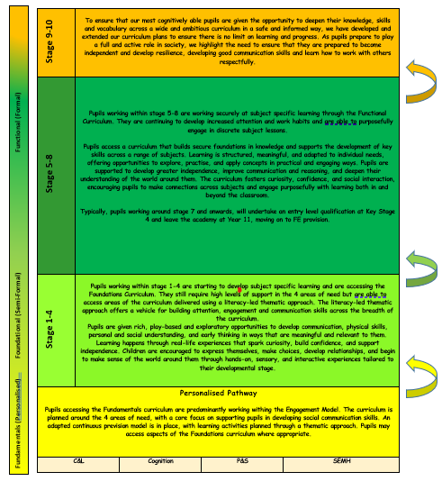
Fundamentals, Foundations and Functional Curriculum (FFF)

Sitting behind our Progressive Pathways model are our Fundamentals, Foundations and Functional Curriculums (FFF) – the culmination of years’ worth of curriculum evolution and the product of a vision to create the curriculum interplay content that enables our teachers to truly meet the needs of every one of our pupils.

Fundamentals Curriculum
Our ‘Fundamentals learners’ are those pupils with severe learning difficulties and/or complex needs, who need an individualised approach to learning. The pupils would typically have a range of overlapping needs, for example social communication difficulties, attentional difficulties and/or medical needs. The curriculum is available to pupils across all key stages dependent on need.

Our aim of the Fundamentals Curriculum is to provide personalised, holistic, broad, balanced and relevant learning experiences which equip and engage pupils with a range of knowledge, skills and understanding.

- Support pupils to become confident communicators across a range of settings
- Promote personal, social emotional and cultural development
- Develop functional adaptive life skills to promote independence
- Promote active involvement in community experiences and provide cultural capital

Aspects of this curriculum uses a range of methods and approaches best suited to the pupils learning and development needs including:

- Multisensory approaches
- Experiential learning
- Concrete learning opportunities
- Small step learning approaches with opportunities for practise in a range of everyday contexts

Pupils accessing this more personalised curriculum reflects pupils’ specific needs, interests, motivations and aspirations. The starting point for their personalised journey is based on the outcomes derived from their Education Health and Care Plans. Following initial assessment, pupils have a Personalised Learning Plan (PLP) which drives all aspects of curriculum delivery. PLPs are updated termly and each student is expected to complete 3 PLP cycles within their Annual Review period on a rolling schedule (although this may not always follow the academic year).

We aim to support those pupils who are able to access subject specific lessons in the wider school at a developmentally appropriate stage. Decisions to support a pupil to access the wider school curriculum are based on a range factors, e.g. academic ability, attentional skills, communication skills and being socially and emotionally ready to take next steps

Our ‘Fundamentals’ Curriculum will:

- Develop positive social relationships, within school, home and the wider community
- Develop a range of social, communication, interaction and practical skills, empowering pupils to become active learners and members of their community
- Develop life skills and everyday functional literacy and numeracy skills
- Develop confidence and celebrate pupil achievements
- Enable pupils to communicate their likes and dislikes, feelings, hopes and aspirations for the future
- Develop skills to make friends, make active choices and develop a sense of belonging within the wider community
- Develop safe and healthy lifestyles

Foundations Curriculum

Our ‘Foundations learners’ are those pupils with moderate to severe learning difficulties who may also have overlapping additional needs such as social emotional needs, communication and interaction needs and/or sensory needs.

Our aim is to provide broad, balanced and relevant learning experiences which equip and engage pupils with core subject knowledge, skills and understanding alongside structured, planned learning experiences which address their individual areas of need.

- Support pupils to develop and apply relevant academic knowledge to a wide range of contexts
- Support pupils to become confident communicators across a range of settings
- Promote personal, social emotional and cultural development
- Develop functional adaptive life skills to promote independence
- Promote active involvement in community experiences and provide cultural capital

Aspects of this curriculum pathway use a range of methods and approaches best suited to the pupils’ learning and development needs including:

- Focussed formal subject specific lessons for core subjects
- A spiral curriculum that builds on and further develops “sticky knowledge”
- A relevant, developmentally appropriate, aspirational thematic approach
- Experiential and concrete learning opportunities

Pupils’ accessing the ‘Foundational’ aspects of the curriculum are initially assessed using a range of in-house and professional assessments to determine specific need. The Foundations curriculum is comprised of two main elements:

- Core subject lessons and formal, differentiated learning
- Individual learning outcomes using personalised learning plans (PLPs)

Pupils’ progress is evaluated using our in-house assessment tool which monitors their formal learning against an adapted version of the National Curriculum. The pupils' progress on their personalised outcomes is evaluated against the outcomes set on their Education, Health and Care Plan.

Our Foundations Curriculum will:

- Ensure pupils are able to use “sticky knowledge” across a range of contexts
- Achieve developmentally appropriate formal learning accreditation in core subjects
- Develop positive social relationships, within school, home and the wider community
- Embrace a range of social, communication, interaction and practical skills, empowering them to become active learners and members of their community
- Give opportunities to apply life skills and everyday functional literacy and numeracy skills
- Develop confidence and celebrate achievements
- Enable pupils to communicate their likes and dislikes, feelings, hopes and aspirations for the future
- Develop interpersonal skills so that pupils have the ability to make friends, make active choices and develop a sense of belonging within the wider community
- Teach pupils how to live safe and healthy lifestyles

Functional Curriculum

Our ‘Functional’ Learners are those pupils with moderate and other SEND identified needs such as ADHD, Autism and/or speech, language and communication difficulties.

For these pupils, the aim is to provide an adapted version of the National Curriculum which will challenge our most able pupils to build on and extend their knowledge in core subject areas and additional subject specific areas whilst still developing the broader social skills needed to thrive and be fully prepared for their next steps.

- Support pupils to develop and apply relevant academic knowledge to a wide range of contexts
- Support pupils to become confident communicators across a range of settings
- Promote personal, social emotional and cultural development
- Develop functional adaptive life skills to promote independence
- Promote active involvement in community experiences and provide cultural capital
- lead to formal qualifications where applicable
- support pupils into mainstream Post 16 settings
- Support learners to develop employability skills via vocational subjects

Aspects of this more ‘Functional’ Pathway use a range of methods and approaches best suited to the pupils’ learning and development needs including:

- Focussed formal subject specific lessons for core subjects and other subject specific areas of the curriculum
- An adapted National Curriculum offering highly adapted learning where necessary
- Formal lessons with opportunities to apply knowledge across a range of contexts
- Experiential and concrete learning opportunities

Pupils’ accessing the more formal aspects of the curriculum are initially assessed using a range of in-house and professional assessments to determine their specific curriculum goals. This provides our most cognitively able pupils with a sequenced and aspirational curriculum that stretches their knowledge, understanding and skills.

Pupils’ progress is evaluated using our in-house assessment tool which monitors their formal learning against an adapted version of the National Curriculum. All pupils (who can!) are expected to achieve formalised and meaningful accreditation in a range of subject areas. In addition, the pupils' progress on their personalised outcomes is evaluated against the outcomes set on their Education, Health and Care Plan.

Our curriculum prepares these pupils for the next stage in their education, training and/or future employment and for life beyond school!

Our Functional Curriculum will:

- Embed “sticky knowledge” across a range of contexts and within employment and PfA opportunities
- Enable pupils to achieve meaningful formal accreditation in core/wider subject areas
- Develop positive social relationships, within school, home and the wider community
- Embrace and develop a range of social, communication, interaction and practical skills, empowering pupils to become active learners and active, confident members of their community
- Give opportunities to apply academic subject knowledge within functional literacy and numeracy skills and across the wider curriculum
- Develop confidence in learners and celebrate achievements
- Develop communication skills so that pupils can independently communicate their likes and dislikes, feelings, hopes and aspirations for the future
- Enable pupils to make friends, make active choices and develop a sense of belonging within the wider community
- Teach and develop pupils to understand and make choices that support safe and healthy lifestyles

CPA Community Values

Whilst children will always sit at the centre of everything we do, we also recognise the value that our parents, carers, staff team and governors contribute to our wider school community.

Our community values are at the forefront of our decision making as we look to build a strong and sustainable culture of mutual respect and belonging for all of our stakeholders.

We expect everyone to:

- Communicate openly and honestly

- Treat one another with respect, dignity and kindness

- Support, signpost and show empathy

- Have professional pride in our school

- Work effectively as a team

- Place the child at the centre of every decision



